CEG 4750/6750 Information Security

Lab/Project 1
Using DES Algorithm

A project submitted in partial fulfillment of the requirements for the
CEG 4750/6750 Information Security

By

Bhuwan Pandey (U01155118)
Bipin Poudel (U01151906)

2026

WRIGHT STATE UNIVERSITY

Introduction
In this project, the DES encryption/decryption programs are provided, and the students (we) will compile and run these programs to encrypt/decrypt files on fry.cs.wright.edu. The DES encryption/decryption programs used an existing crypto library, Crypto++ (C++), which was installed on fry.cs.wright.edu.
For the project, the very first thing we did was to connect to fry.cs.wright.edu and access the shell to do the work. To avoid custom mess and/or inconsistency, we copied the provided files along with directory as it is – to the server and began working. And by ”as it is”, we mean extracted version of the directory, not the compressed file itself.
After copying the directory to the root of our profile in the server, the ls command showed the following (Figure 1.1). Now, since all the necessary files are under the directory Project 1 attached files Mar 8, 2026 1015 AM, we had to change current working directory to that directory.
Figure 1.1 – Current working directory
As per the instruction provided and for our own ease, we created an alias called cryptog++ for the command as shown in the Figure 1.3 below. This helped us avoiding typing such a long command each time we try to compile our program.
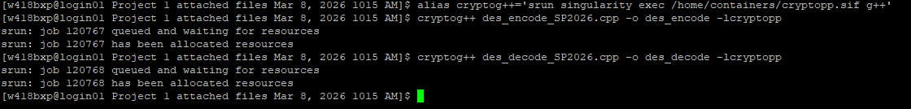
Figure 1.2 – Alias and compilation
Also as demonstrated in the above Figure 1.2, we can see that the alias is working perfectly as the compilation of both the encryption/decryption program works. Now, we begin along with the task that we are supposed to complete.

Task 1
For Task 1, we are required to compile and execute the provided source DES encryption/decryption programs, and verify the decrypted file is identical to the original plaintext file. There are total of 5 test files provided to us for the task, which are MSG1, MSG2, MSG3, text1, hw2.pdf.gz. And for each file, we are required to do the following:
- Encrypt the file to output it suffixed with .e to indicate it as an encrypted file.
- Decrypt the file to output it suffixed with .d to indicate it as a decrypted file.
- Compare the bytes of couple of encrypted files.
- Show the difference between two files (the original and the decrypted) to demonstrate the working nature of overall process.
For the subtasks requested, we began encrypting each of the input files one by one as shown in the Figure 1.3 below.
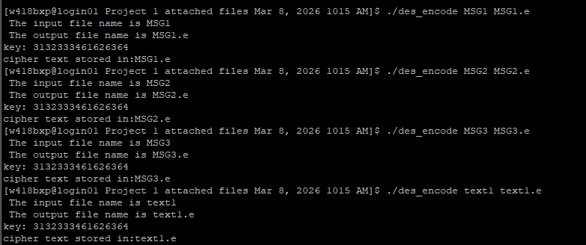
Figure 1.3 – Encryption of input files
Similarly, we tried decrypting the encrypted files as shown in the following Figure 1.4.
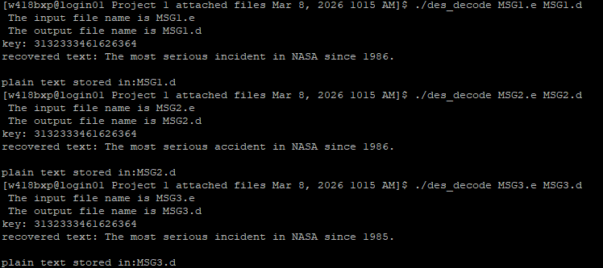
Figure 1.4 – Decryption of encrypted files

Task 1.1
So far, so good. For the subtask 1.1, we print the octal byte values using the command od –b filename for each file as shown in the below Figure 1.1.1.
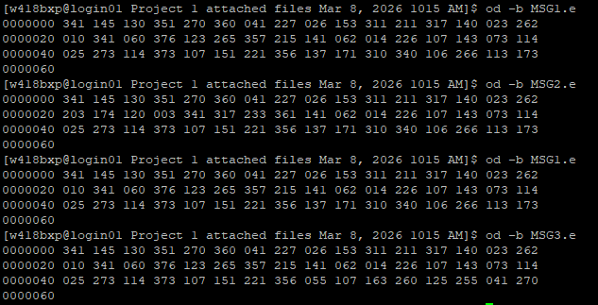
Figure 1.1.1 – Octal byte values of encrypted files

Task 1.2
From the above Figure 1.1.1, we can conclude for the comparison of MSG1.e and MSG2.e that there are total of 8 bytes of difference as in the second row – the byte difference starts from the first segment to all the way up to 8th segment.
Similarly, for the MSG1.e and MSG3.e, the third row indicates that there are total of 8 bytes difference starting from 9th segment to all the way up to 16th.
This overall difference is actually expected with DES as its block size is 8 bytes and changing one block affects exactly one ciphertext block.

Task 1.3
We are required to use diff command to show the difference of two files (the original file, and the decrypted file). The result is shown in the Figure 1.3.1 below:
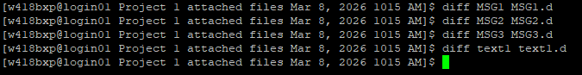
Figure 1.3.1 – Difference between files
As we can observe from the above Figure 1.3.1, we can clearly conclude that the encryption and decryption works perfectly as there are no differences shown for all the comparisons made.

Task 2
For this task, we are provided with the source DES encryption/decryption programs that performs in ECB mode. We are required to change the source code files of the DES programs, so that the programs are working in CBC mode while still verifying that the decrypted file is identical to its original plaintext file.
The below Figure 1.2.1 shows the modification made in the function des_encode and main. We have added a parameter of byte iv[] and tweaked the DES to operate on CBC_Mode. The very similar logic is applied to the decryption program as shown in the Figure 1.2.2. Both the file’s name are des_cbc_encode_SP2026.cpp and des_cbc_encode_SP2026.cpp. These files are saved as separate ones and renamed to isolate each programs from the other.
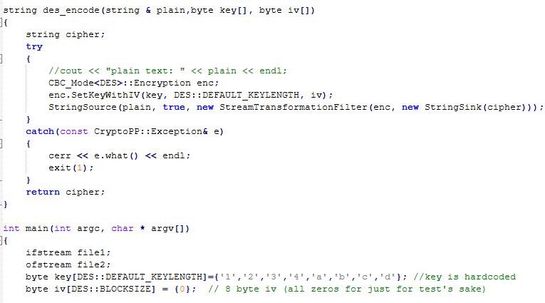
Figure 1.2.1 – Encryption program in CBC mode
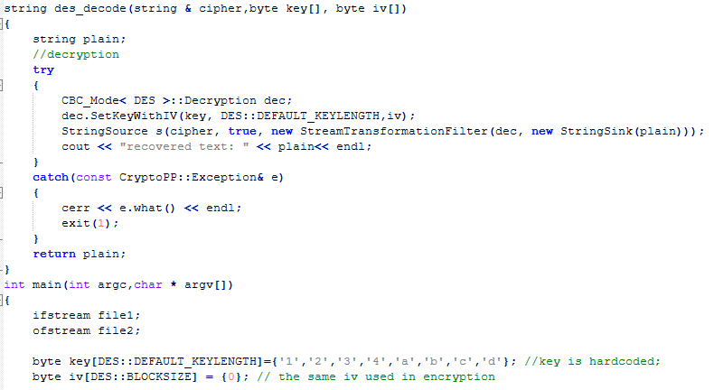
Figure 1.2.2 – Decryption program in CBC mode
As we have noticed already, the CBC mode requires an initialization vector (IV) to encrypt and decrypt a file where the size of the IV is set to the DES’s default length. i.e. 8 bytes typically. The below Figure 1.2.3 shows the compilation of the two programs on CBC mode, the Figure 1.2.4 shows the encryption of the files, the Figure 1.2.5 shows the decryption as well as the comparison between them.
Figure 1.2.3 – Compilation of programs on CBC mode

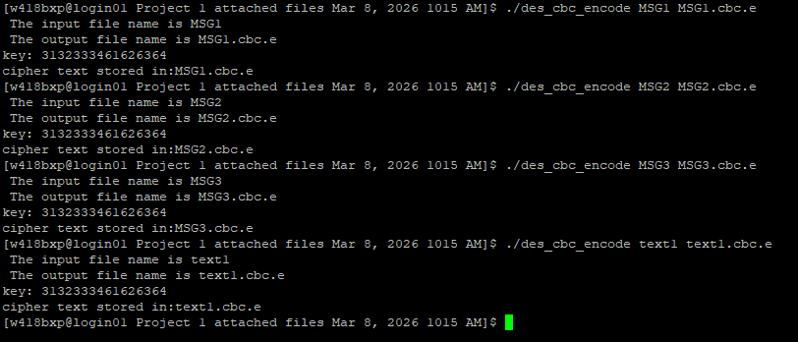
Figure 1.2.4 – Encryption on CBC mode

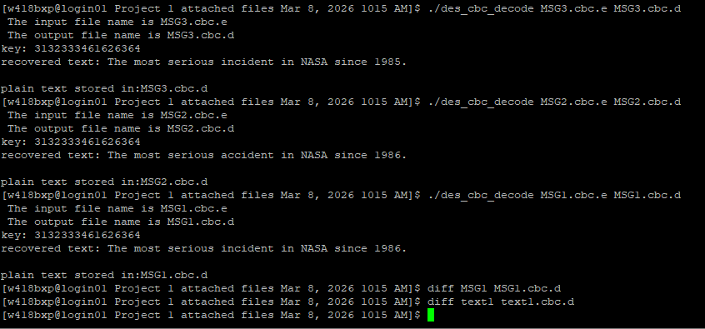
Figure 1.2.5 – Decryption on CBC mode

Task 3
This task requires us to change the source code files of the DES encryption/decryption programs which has its key hardcoded. The changes needs to be such that the key would be entered through the command line as the 4th input argument. The below Figure 1.3.1 and Figure 1.3.2 shows the tiny changes made in encryption and decryption program respectively. The file’s name are des_KEY_PARAM_encode_SP2026.cpp and des_KEY_PARAM_decode_SP2026.cpp respectively for the encryption and decryption program.
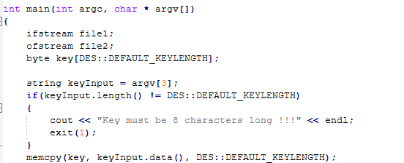
Figure 1.3.1 – Encryption program with key parameter

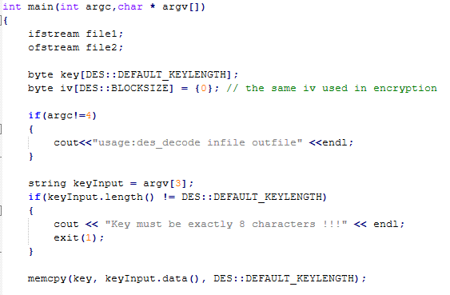
Figure 1.3.2 – Decryption program with key parameter
If we observe carefully on both the programs, we can see that we have removed hardcoded array of keys and are using the third (starting with 0) parameter as a key instead. It is to be noted that the length of the key should be the algorithm’s default segment/block size. i.e. 8. The following Figure 1.3.3 and Figure 1.3.4 shows the successful encryption and decryption of the files respectively.
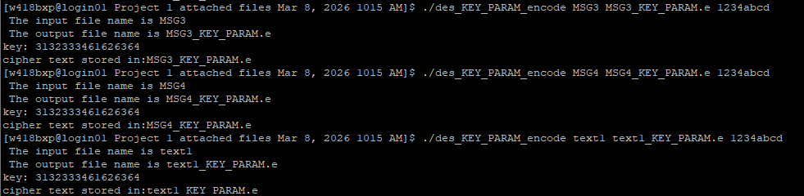
Figure 1.3.3 – Encryption of files with key parameter program (encryptor)

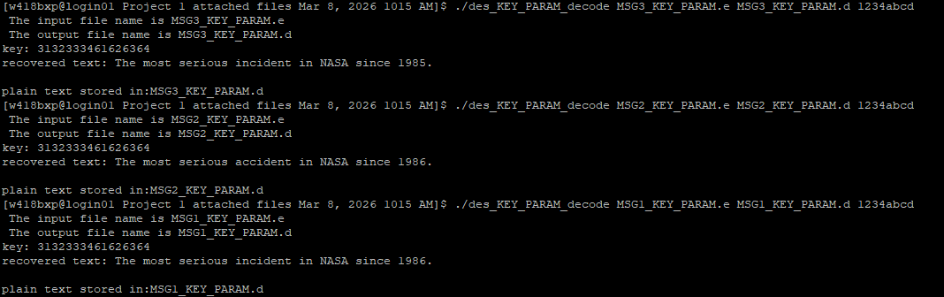
Figure 1.3.4 – Decryption of files with key parameter program (decryptor)
While the program seemed to run perfectly fine, we still needed to check the difference between the original file and its decrypted equivalent just to make sure that integrity is not lost. The below Figure 1.3.5 shows the difference between the files MSG1 and text1, and the octal bytes value resulting similar output as it did in previous tests. To save time and effort, we assume that if the program succeeds on encrypting those two files, it succeeds on any.
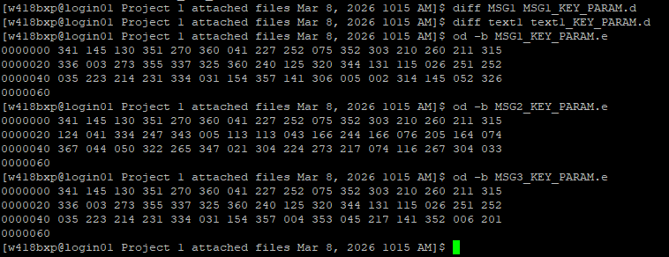
Figure 1.3.5 – Difference between files

Conclusion
This project provided practical experience with symmetric encryption by implementing and modifying DES encryption and decryption programs using the Crypto++ library in a Linux server environment. By compiling and executing the provided programs on fry.cs.wright.edu, we verified the correctness of the encryption/decryption process by confirming that the decrypted files were identical to the original plaintext files. Through the comparison of ciphertext outputs using the od command, we observed how small differences in plaintext propagate to changes in ciphertext bytes. Additionally, modifying the implementation from ECB mode to CBC mode helped illustrate the importance of block cipher modes in improving cryptographic security.
Finally, allowing the encryption key to be supplied through command line arguments improved the flexibility and usability of the program. Overall, the project strengthened understanding of DES operations, block cipher modes, and practical use of cryptographic libraries in real computing environments.

